Autoscaling group with simple scaling in dynamic type.
Steps :-
- Create a autoscaling group
- For autoscaling group create launch template and attached to the autoscaling group
- Once autoscaling group created, please vefired the INSTANCE has created or not due to autoscaling group
- If instance running fine create a two dynamic autoscaling policy(1 scale increase and 2nd is scale decrease) with the help
- While creating the dynamic policy need to attached cloudwatch alarm for both policy (scale in and scale out)
- Once both alarm created need to attach in both policy respectively
- For verification, install the stress command as mention below and run one of the server
If stress is increase automatically server is increase
- Create a autoscaling group
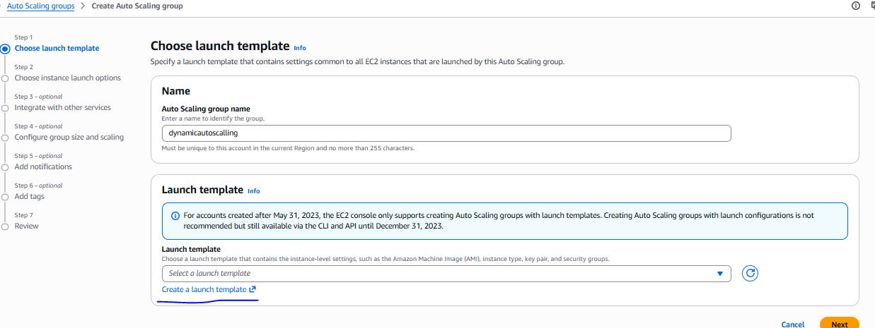
For autoscaling group create a launch template.
Launch template has been created
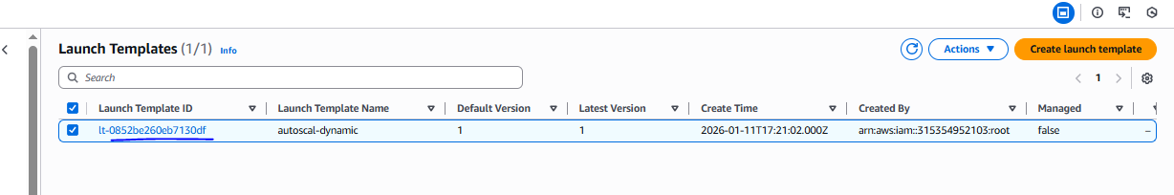

Two instances has been created with the help of template and autoscaling group.
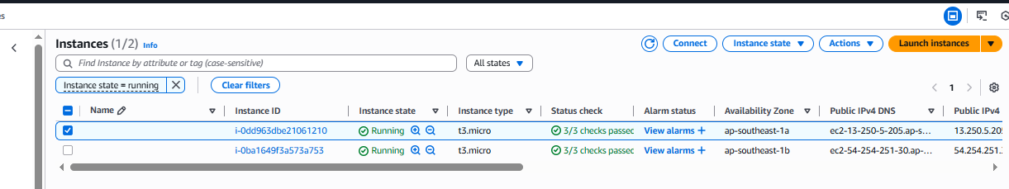
We need to perform dynamic autoscaling with simple dynamic type
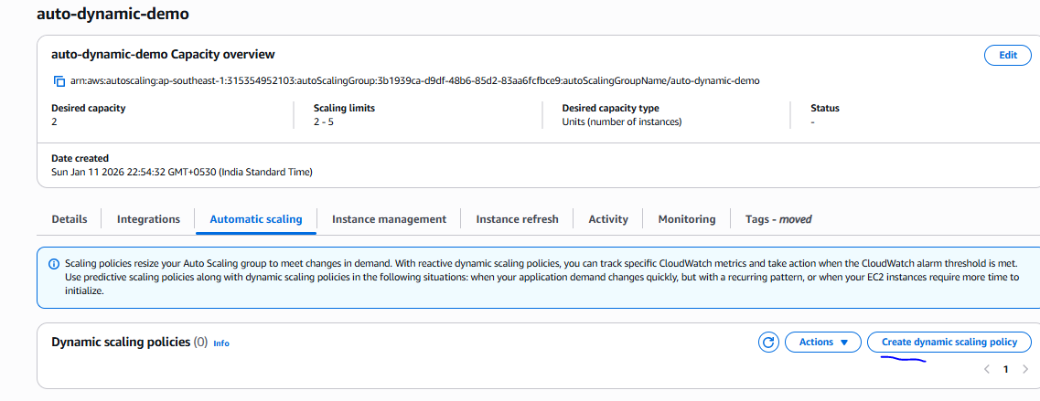
Create a cloudwatch alarm to monitor CPU uitlization

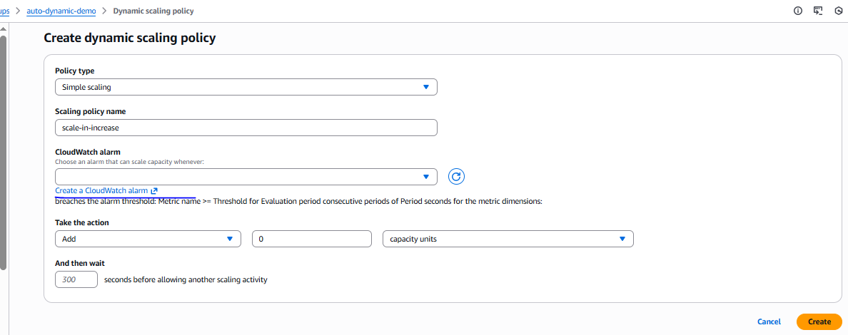
1st alarm has created to scale increase with basis of CPU utilization
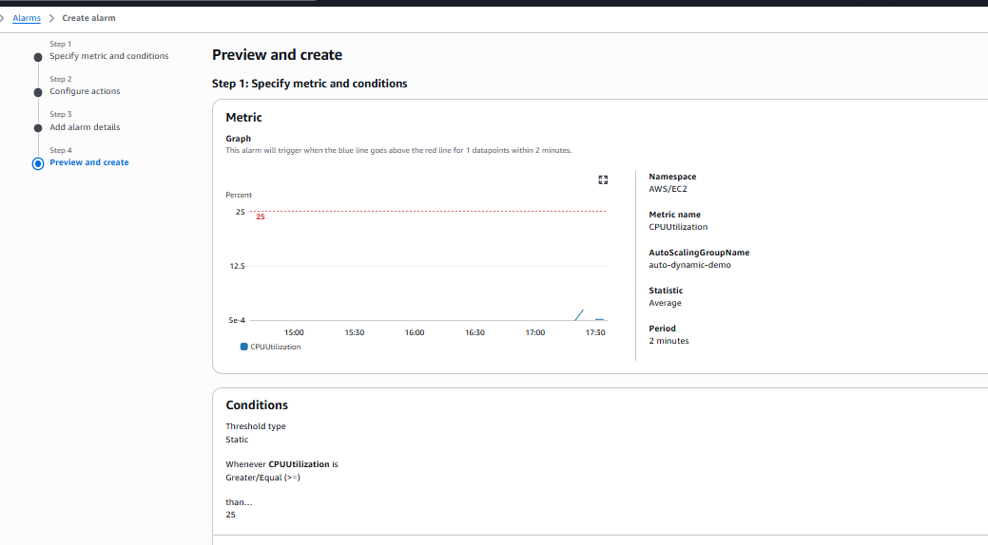
Once alarm has created need to add this alarm in the scale in dynamic policy
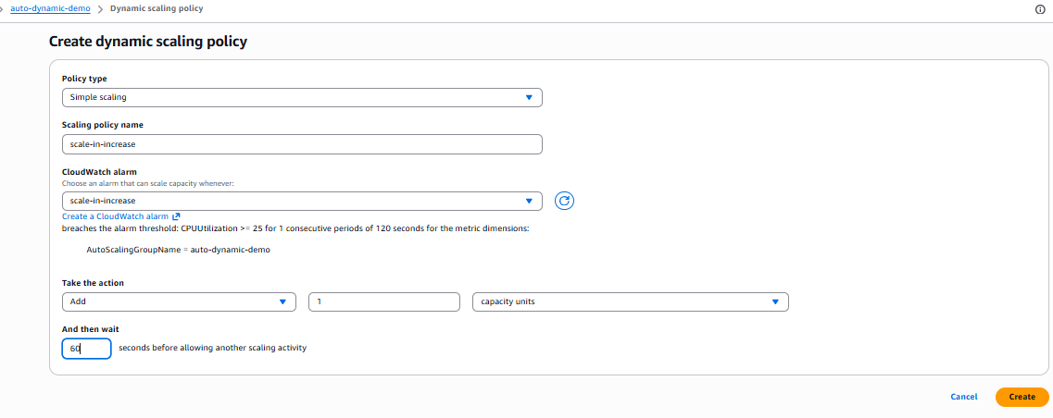
Similarly need to create policy for scale-out
Scale-out dynamic policy also has created
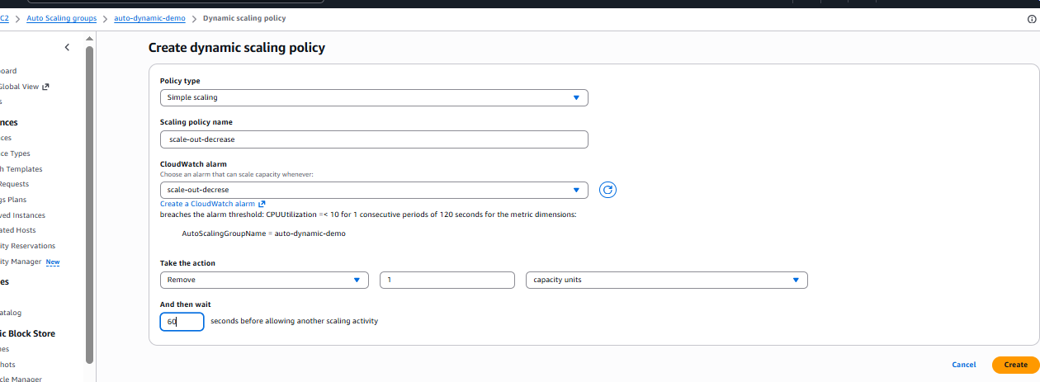
Verified:
For scale in –increase
Need to add the load using below command
yum install stress -y--------------------------for installation
stress --cpu 20 --timeout 1000 ------------------increase the stress
scale in load increase instance increase
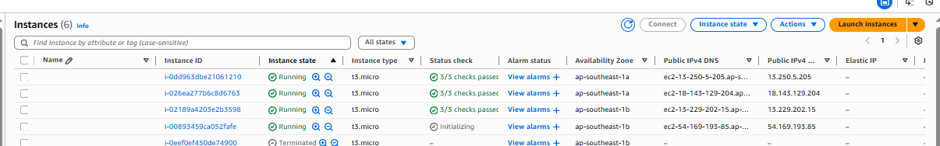

Scale out load decrease instance remove
